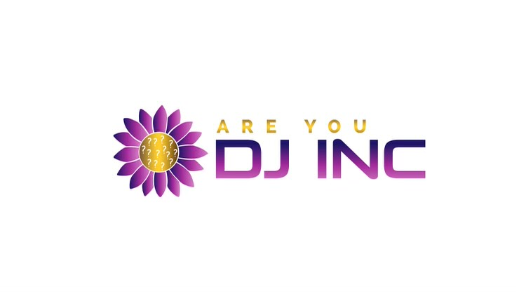 |  | ARE YOU DJ INC.  Volunteer Form
Mission  We strive to bring resources, program and workshops within the Bipoc community in order to educate and change the narrative on the stigma the community has on substance use disorder.  Contact  PHONE:  386-601-9332  WEBSITE:  Areyoudj.org  EMAIL:  awareness@areyoudj.org  Volunteers needed for:  Narcan distribution  Food drives  Peer advisor  Event set up  mentorship  Are you DJ Inc volunteers must be 18 years or older.  We welcome high school Juniors and Seniors to volunteer with parental consent. |  | Name:  Age:  Are you volunteering for community service Hours?  Yes  No  If yes how many hours are needed?  Are You In Recovery?  If yes are you interested in being a peer advisor?  YY

